GLASS ROOF HOW TO:

Ok, so, for 3 years, I have wanted the glass roof for my CRX, and for 3 years no one would tell me anything. NO ONE! Everyone is so secretive, because they either don’t want anyone to have it, or they are trying to rip people off in doing the install. What I am about to tell you A) You may already know B) Might piss you off cause you are so secretive that its pathetic, or C)Might be the nicest thing you have ever been told, cause you wanted, like me, to do this to your CRX. Now, this is not the complete install info..yet. I still have to install it on my car, and that will not be till July..personal reasons..I will update this as I can, and I will make sure it is bumped up on occasion till the swap is complete. I know how it will all pan out, so I will give you all I know. Here goes:
1) Obtain your complete glass roof consisting of:
-Outer frame
-Glass
-Outer Rubber trim seal..Contrary to belief, you can remove the glass without destroying this, however, if you can find a new one, get it..cause it’s a good thing!
-Headliner
-Map light
-visors..if needed
-inner headliner trim seal..its not really a seal, its more a piece of trim to hold the headliner up to the glass
2) Now that you have your glass roof, take the headliner, and all trim pieces off of the frame, leaving only the glass and outer rubber trim seal.
3) Find a razor blade and box knife, and start cutting the butyl rubber from the inside of the glass roof frame, that way you do not damage the outer seal. The box knife will work a little, then, you need to find something sharp that is longer, and strong enough to pull threw the buytl..I tried all types of things, and cut, and cut and cut. I ended up using a steak knife! If you went to a glass shop, or someplace that sells the tools, you can remove it easily, or the glass shop can. My way took about 2 hours! You have to be patient, and be careful you don’t break the glass.
4) Now that you have the glass out, the rubber seal should still be attached to the outside of the glass. Take your razor, and remove all the left over butyl rubber on the back side of the glass, so when you are ready to reinstall, it will be ready!
5) Now, razor off all left over butyl on the metal frame.
6) You will need to get a ¼” drill bit and use a punch, or get a spot weld removal bit. You will have to remove numerous spot welds, and it will take a while to find them all. I did not strip my roof with paint striper, but if you think it will help you find the welds, do it! The only piece you are trying to keep somewhat decent is the top roof skin..its all one piece, from front to back, all one piece. You will have to drill from the top, and from the bottom, depending on where you see the weld. Once you have all the spots free, you will have to take a panel spreader, and make sure they are COMPLETELY FREE! Once, they are, the outer pillars will separate, and it will all come apart..Just be careful, take your time, and if you see a weld not completely separated. drill some more, or use a narrow chizzle and hammer.
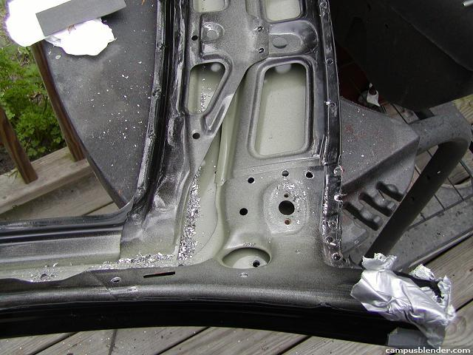
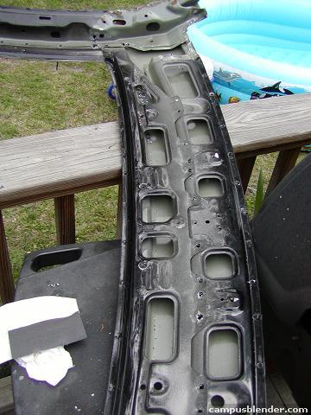
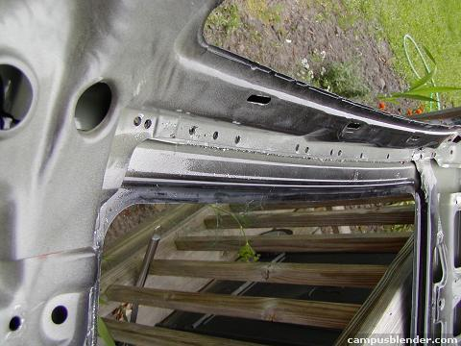
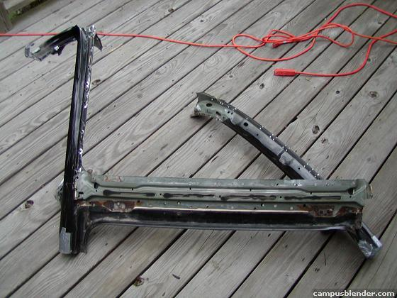
7) Now, notice in the photo there is a semi-structural piece still attached to the roof skin, you need that, it supports the front edge of the roof panel. Just drill out the welds to the front and side of it, like I did in the pics. You can get it out still attached to the roof skin
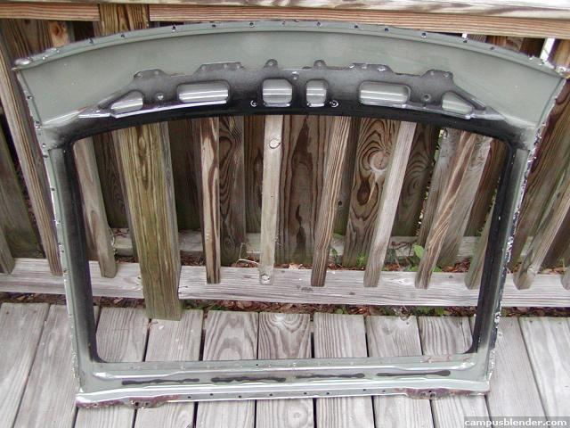
8) Now that you have the panel completely removed, that is the only part of that metal frame you need. I compared the understructure of my CRX Si with sunroof, to the glass roof frame, and guess what, there was no difference. That outer skin is the only difference! Thanks Honda!
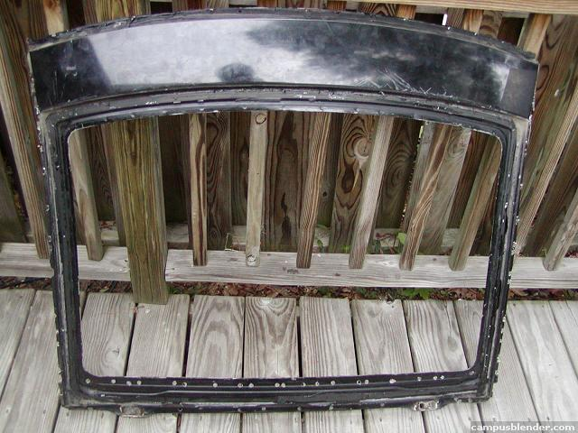
9) So, this is as far as I have gotten. You now have two paths you can walk. You can drill the spot welds on your car, and put this skin in its place with more spot welds, and seam sealer..Or you can do the route I am choosing to take. I am using a product called Fusor, by Lord Products. I am including a link to their site..and a link to their step by step roof skinning process in which I am using..Their process requires no removal of any welds on your roof, you basically cut the old roof off, and use an overlap method. Remember, every area on your roof, has a trim piece, so no one will notice the 1/32” elevation change in your roof..Hell, 90% of the roof is glass, with a rubber trim edge. Its so easy its CRAZY! This is why some people do not want you to know about it.
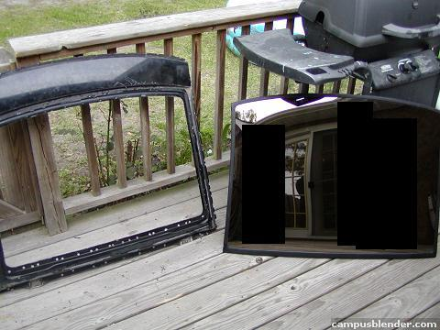
http://www.lord.com/Default.aspx?tabid=1150&pid=5
http://www.lordfulfillment.com/upload/RP3003.pdf
BTW, no welds were used in my process, just Duramix panel adhesive. Its unbelievable strong, and the chassis is a lot stiffer. Mike
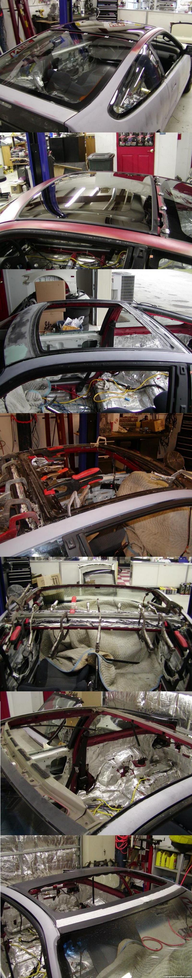
NOW, SOME QUESTION AND ANSWER:
Where did I buy the glass roof? Local importer..he is now sold out, but may go back to japan next year for more, and other parts.
Am I worryed about it cracking? HELL YES! who wouldnt be! lol..I am in the process of purchasing an extra piece of glass now just in case anything ever happened. If you have one, let me know, i may buy it!
Did i go ahead and glue in the glass? Yes, I used window byetal (however you spell it!), I already primed and base coated under neat, so working around it to paint will be a breeze. I dont have the luxury of a garage to do this, so i have to do everything during the weekend at the shop I work at part time.. http://www.jkmsports.com
Am I willing to do this again for others? Yes, if the price is right!
Structurual adhesive vs. spot welds...the true story? Ok, Structural adhesive, its a great great product, extremely durable. Quality..well, let me put it this way..if a normal panel that is spot welded can withstand 1200psi of tearing force, the duramix adhesive has been proven to hold 1500psi. It is approved by the automotive safety institute. Its much easier. My car is 10 times stiffer than it used to be. In between the metal roof layers near the hatch, i had slight surface rusting, and when you jacked the car, you could see twist, and opening the door would cause a very very slight touching of the jamb striker...Now, i can lift the rear up 2' in the air, and open the door with ease..with the glass installed. If the glass ever breaks from stress i would be highly supprised. Besides, I have A-sports fender bracing, I will have EM racing 3 peice bars, and strut tower bars..Should be fine. Also, the glass that is in the glass roof, is tough as nails. Its very thick, it has titanium coatings inbetween the layers..Honda knew it would have to be tough. As long as the installation is strong, your fine. the internal skeleton of the crx is identical in the SI, DX, HF, and Glass roof models..Only the roof skin, and one upper rear structural panel is different. Its cake.
Do you have to remove the front windshield? Nope...I used whats called the overlap technique. You dont actually remove the front roof skin, you overlap you new one. Makes it easy. I beat the hell out of the front after the roof was cut off, and the windshield just flexes with it..Glass is a lot tougher than you think!
Weight of the glass roof? Well, It is proven the Glass roof assembly vs. the SI sunroof assembly is 10 pounds LIGHTER! Yes, Lighter..Think about it, you remove all the metal in the center..Metal is heavier than glass.
Here it is, finally, with its paint
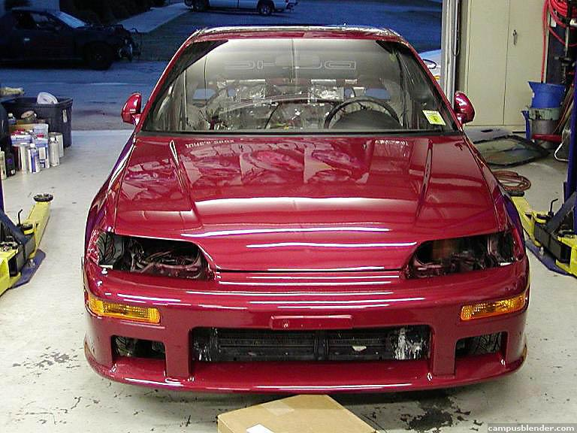
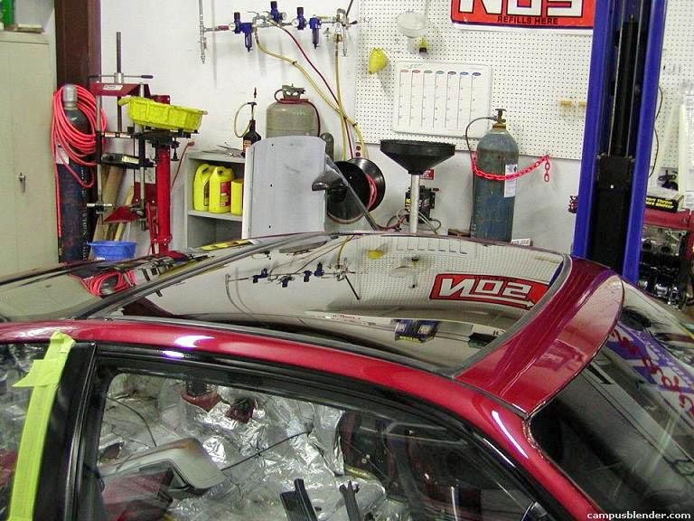
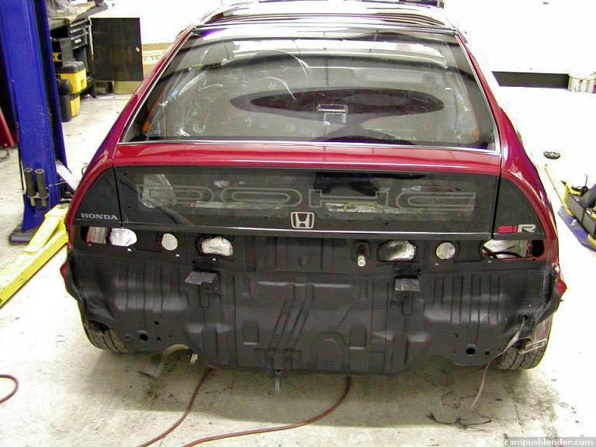
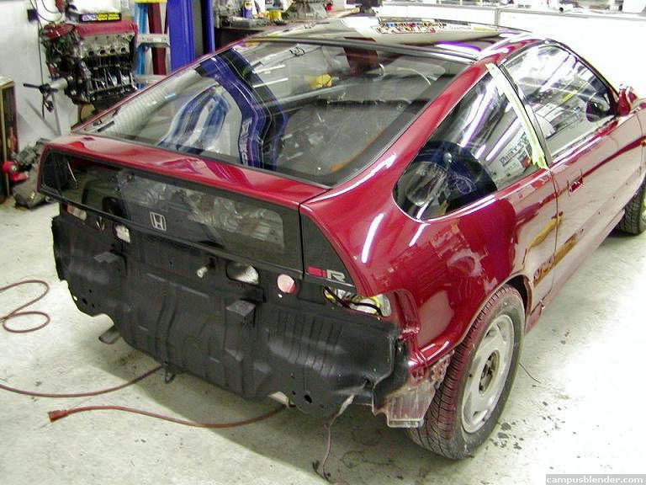
NEW***** QUESTION AND ANSWER WITH A FRIEND THAT IS DOING THE GLASS ROOF..SHOULD ANSWER SOME PEOPLES QUESTIONS:
[16:08] Mike: you doing the roof soon?
[16:09] - role model -: yeah i found one D:
[16:09] - role model -: and i was reading your how to do it
[16:09] Mike: oh cool
[16:09] Mike: good deal
[16:10] Mike: how much did you have to give for it?
[16:10] - role model -: 700$ CANADIAN
[16:10] - role model -: A1 clean
[16:10] Mike: excellent
[16:10] - role model -: so about 625-650$ US
[16:10] Mike: very good
[16:10] - role model -: yeah
[16:11] Mike: so when does the choping begin?
[16:11] - role model -: this week if i understand everything you wrote
[16:11] Mike: cool
[16:11] - role model -: cuz it kinda weird the overlap process
[16:12] Mike: well, take your time
[16:12] Mike: you using duramix?
[16:13] - role model -: i was thinking at first removing all spot weld and removing the complete roof and then replace it with the new one with spot weld but then i learn how u did yours and i was like hmm... witch one would be better now
[16:13] Mike: the duramix is much stronger than spot welds honestly
[16:13] Mike: my chassis is much stiffer now than before
[16:14] Mike: and its Auto institute of crash safety approved to be stronger than oem
[16:14] - role model -: kkk
[16:14] - role model -: where can i find that
[16:14] Mike: not sure with you being in canada
[16:14] Mike: there are online sites that sell it, and the applicator gun
[16:15] Mike: i got mine at auto tool mart online
[16:15] - role model -: kk
[16:15] - role model -: do you think uap or napa has it
[16:15] Mike: you have to get the structural metal version tho, so make sure you look it up
[16:15] Mike: napa should be able to order it
[16:15] - role model -: ok
[16:15] - role model -: structural metal version
[16:16] Mike: yes, structural metal adhesive
[16:16] Mike: panel adhesive
[16:17] - role model -: im on the site
[16:17] - role model -: http://www.lord.com/Default.aspx?tabid=1150&pid=5
[16:17] - role model -: and their is like 3
[16:17] Mike: yeah, lord/ fusor is the other brand
[16:17] - role model -: med-set
fast-set
slow-set
[16:17] - role model -: witch one should i take
[16:18] Mike: http://www.lordfulfillment.com/upload/RP3003.pdf
[16:18] Mike: read that too
[16:18] - role model -: ok
[16:18] Mike: that explains the overlap technique
[16:18] - role model -: yeah i read it
[16:19] Mike: k
[16:19] - role model -: but the probleme is the back and the side
[16:19] Mike: how?
[16:19] - role model -: where u need to cut it
[16:19] - role model -: in the back and on the side
[16:19] - role model -: 2 inch ?!
[16:19] Mike: well, I think each person will do that a little different
[16:20] Mike: i only used the top later, and not all the way back to the trunk seal
[16:20] Mike: the top layer stops right past the hatch hinge bolt
[16:20] - role model -: yeah i know
[16:21] - role model -: so i should put all of it on top of the hatch
[16:21] Mike: yeah, but test fit
[16:21] - role model -: kk
[16:21] Mike: if it doesnt work quite right, trim it up some
[16:21] - role model -: alright
[16:22] Mike: you just need enought overlap to get a proper bond
[16:22] Mike: see i did a test install on a doner car before I ever cut mine
[16:22] - role model -: but i dont have a doner car
[16:23] Mike: lol, well, then you definately need to plan and plan again
[16:23] Mike: I planed for 3 months before every cuting anything
[16:23] - role model -: hmm
[16:23] - role model -: i see
[16:23] - role model -: i was thinking of doing it in a month so i can ship it to the body work for paint after that
[16:24] Mike: http://www3.3m.com/catalog/us/en001/...er/output_html
[16:25] - role model -: you use that ?!
[16:25] Mike: yup
[16:25] - role model -: is that all i need
[16:25] Mike: yup, two tubes, and the applicator gun
[16:25] - role model -: ok
[16:26] - role model -: and the aplicator gun do u have the site for it
[16:26] Mike: its made by duramix
[16:26] - role model -: ok
[16:26] Mike: just find a dealer, and they have the gun
[16:26] - role model -: and for the glasstop did u use eurethane
[16:27] Mike: yup, 3M window seal..just like a windshield is installed
[16:27] - role model -: kk
[16:27] - role model -: and for removing the glasstop of the roof what did u did
[16:28] Mike: well,i now recommend heading a putty knife with a propane torch, and go from the inside with teh putty knife, and you will cut right threw the old stuff without ever damaging anything, or prying on the glass
[16:30] - role model -: would it work with the windshield and rear side windows too ???
[16:31] Mike: yup
[16:31] Mike: works with any of that
[16:31] Mike: and its much better
[16:31] Mike: and easier
[16:31] Mike: and less likely to damage something
[16:31] - role model -: cuz i was using a fishing cord
[16:31] - role model -: lol
[16:32] Mike: haha, well, this way is much easier
[16:32] - role model -: yeah i was burning my hand and fighting with the window
[16:32] Mike: Hey, do you mind if I use this conversation to add to my page with the glass roof info..it should help answer some peoples questions
[16:33] - role model -: its alright
[16:33] - role model -: D:
[16:33] Mike: cool cool
[16:33] - role model -: on witch page
[16:33] Mike: cr-xcentral.com
[16:33] - role model -: ah ok
[16:33] - role model -: the topic is not lock ?
[16:34] Mike: I am an owner of that site, lol
[16:34] - role model -: ohhhhhhh
[16:35] - role model -: Duramix™ Manual Dispenser, 04997, 6 fl oz, 10 per case
High quality gun for heavy-duty dispensing of 6 oz cartridges. Protects cartridge and dispenses cartridges with broken flanges.
[16:35] Mike: for 6oz cartirdges

